Campaign Ambassador Sample Emails to Send to Your Employees

Table of Contents
Week Prior To Campaign Starting 2
Campaign Kick Off to Staff 1 3
Campaign Kick-off to Staff 2 4
Campaign Kick-off to Staff 3 – 2020 Pandemic 5
Campaign Kick Off to Staff – 2020 Goals 6
Virtual Backgrounds 7
Follow-up/Motivational Message 1 8
Follow-up/Motivational Message 2 9
Follow-up/Motivational Message 3 – Thank you! 11
Follow-up/Motivational Message 4 12
Follow-up/Motivational Message 5 – Why do you give? 13
Follow-up/Motivational Message 6 14
Follow-up/Motivational Message 7 – Thank you! 16
Follow-up/Motivational Message 8 17
Follow-up/Motivational Message 9 – One Week Left of Campaign 18
Follow-up/Motivational Message 10 – One Week Left of Campaign 19
Follow-up/Motivational Message 11 – Final Week 19
Follow-up/Motivational Message 12 – To Exceed Your Goals 20
Thank you after the campaign – Message 13 21

Week Prior To Campaign Starting

Hi friends,

I am cordially inviting YOU to a virtual VtSHARES pledge party on XX at XX (calendar invite to follow)! View the attached video for your personal invitation from me, your VtSHARES Campaign Ambassador!

What’s VtSHARES? Well, it’s the State of Vermont’s annual initiative that asks SOV employees to make a charitable contribution to the eligible VT nonprofits of their choice. Employees can donate as little or as much as they’d like through a one-time paycheck deduction in January, or from each paycheck throughout 2021. As little as $1 per pay period -$26 total- can make a huge difference in the life of a Vermonter. This year’s campaign runs XX-XX.

What’s in it for you? Well, VTLIB employees who donate in the first week of the Campaign (XX-XX) will receive a special gift bag from me! Donators can also choose to receive a special VtSHARES pin.

Please visit the VtSHARES website (www.vtshares.vermont.gov) and write down the name of the nonprofit(s) you’d like to donate to, along with their special code. On Monday, you’ll be able to pledge online during our party (with assistance from me, if needed)! You do not need to stay the entire hour – just pop in when you’re ready! Of course, if you’d rather pledge on your own time during the first week, feel free! Just let me know you’ve donated if you’d like a special gift bag from me.

I’ll send a reminder email on Monday with this information, too. See you soon!

Happy donating,

Campaign Kick Off to Staff 1
Good morning everyone,

As many of you already know, each year the State runs a charitable giving program called VtSHARES. This year’s campaign runs from Monday, October 5th through Friday, October 23, 2020.

I hope you will take the time to consider giving through payroll deductions to one or many of the great nonprofit organizations here in Vermont. The combined generosity of so many of us impacts the vulnerable in countless ways. All of us – managers and non-managers, classified and exempt - pledge to support hundreds of nonprofits that fund a tidal wave of needs (for the elderly, disabled, less fortunate, animal shelters, land conservation, wildlife conservation, food insecurity and more). We work hard every day to make Vermont a better place, and we are now asking you to consider a contribution to help make someone else’s life a bit better for them as well.

You may simply go to vtshares.vermont.gov, click on the PLEDGE link and fill in the online form. Not sure which nonprofit organization to choose? The website also provides the list of approved nonprofit organizations.

I hope we can exceed our contributions this year – and I’m sure we can with your help. Please feel free to reach out with any questions you may have.

Thank you for your time and consideration.

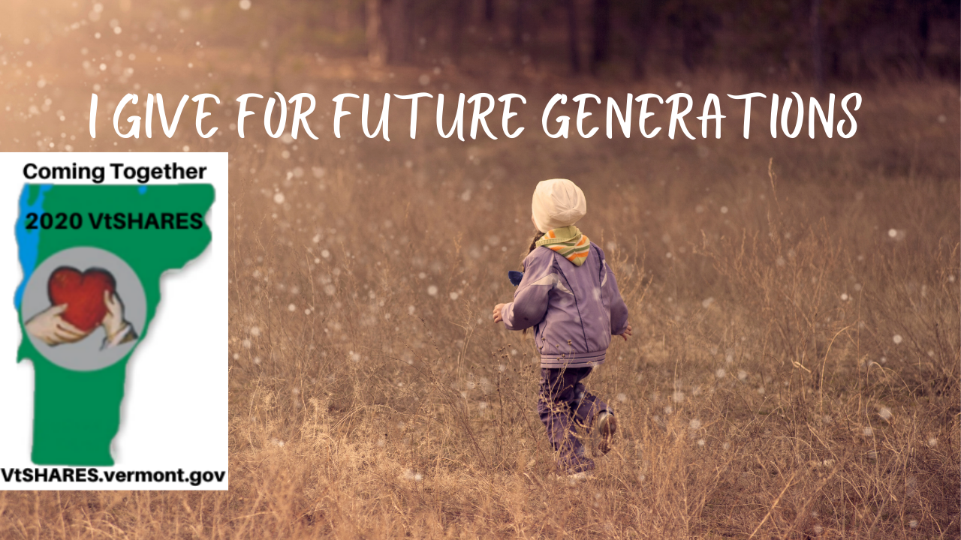

Campaign Kick-off to Staff 2

Good Morning,

It’s VtSHARES time! For those who are not familiar with VtSHARES, it is an annual charitable campaign that allows State employees to donate to Vermont based nonprofit organizations through payroll deduction. This year’s campaign runs from Monday, October 5 – Friday, October 23 and is completely electronic!

You may wonder why you should participate, well, there are many reasons:

- You get to choose where your money goes;
- It has an impact on our communities;
- It gives nonprofits a general fund to fulfill their mission;
- It allows Vermonters to support Vermonters;
- And…. It’s a really easy way to take advantage of the Vermont Charitable Tax Credit. Want to learn more about this tax credit? Check out our FAQ on our website by clicking here.

You can find out more information or donate now by visiting the VtSHARES Website at
www.vtshares.vermont.gov.

Thank you all!
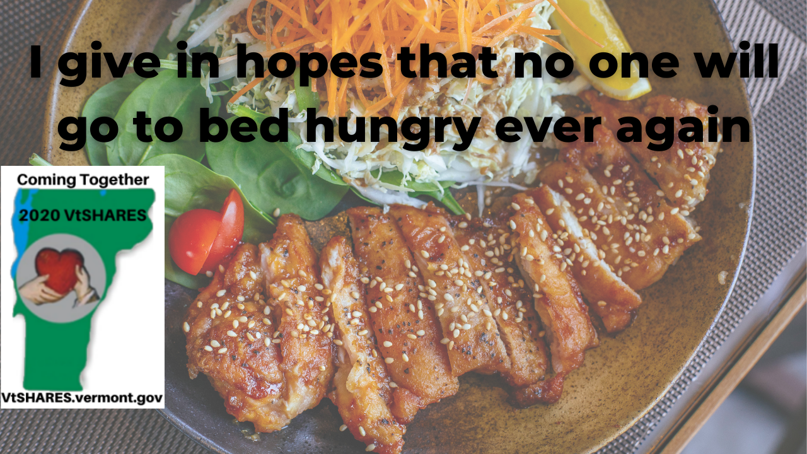

Campaign Kick-off to Staff 3 – 2020 Pandemic

Good morning everyone,

Can you believe that it’s been a year since the amazing success of last year’s VtSHARES Campaign!

Well, here we are again…. and sadly, we all know too well that 2020 has been a year of unbelievable hardships and loss for so many around the world and for our families, friends and neighbors here at home. As a nation, we could never have imagined or foreseen the way our lives have been changed. We’ve witnessed daily, the severity of what has fallen upon our county and the enormity of it has been difficult for us to comprehend. But throughout, we’ve also seen time and time again, the strength and support that unites us and gives us hope!

As for so many, the strength of Vermonters has been tested to its fullest, and as always, through difficult and challenging times, we come together and grow stronger for each other! This is just one of the many reasons that makes Vermont a very special place to live and raise our families. Our communities are strong, compassionate and giving. We are the best of the best at looking out for one another when times are difficult and I know that this year’s 2020 VtSHARES Campaign will explode with the very important support that will get us through this… together!

Please set a reminder to go to: https://vtshares.vermont.gov/ to see all of the amazing Charitable organizations available for us to contribute to that will help our friends, families and neighbors. Your support is so important!

Please reach out to me with any questions that I can assist with.

Thank you all!

Campaign Kick Off to Staff – 2020 Goals

Good morning team,

The 2020 VtSHARES Campaign Season, is underway through 5:00 PM Friday, October 23, 2020. Our collective State goals are to have 940 State employees raise a grand total of $225,593.44. Just imagine what we could do to those goals if each of us pledged $1 every pay period!?!?

I invite you to browse the list of 100 nonprofit organizations to choose from this year and pledge to any that speak to your heart. You may choose to have your donation deducted as a one-time payroll deduction on January 28, 2021, or to divide your total equally by 26 pay periods. Either way, there’s a quick and easy pledge online form for your convenience.

Thank you for the many ways you choose to assist those in need. Should you decide to include VtSHARES as one of those ways and would like to be entered into a drawing to win a sweet surprise, please let me know you pledged and your name will be included in my raffle.

Please let me know if you have any questions or if I may assist in any way.
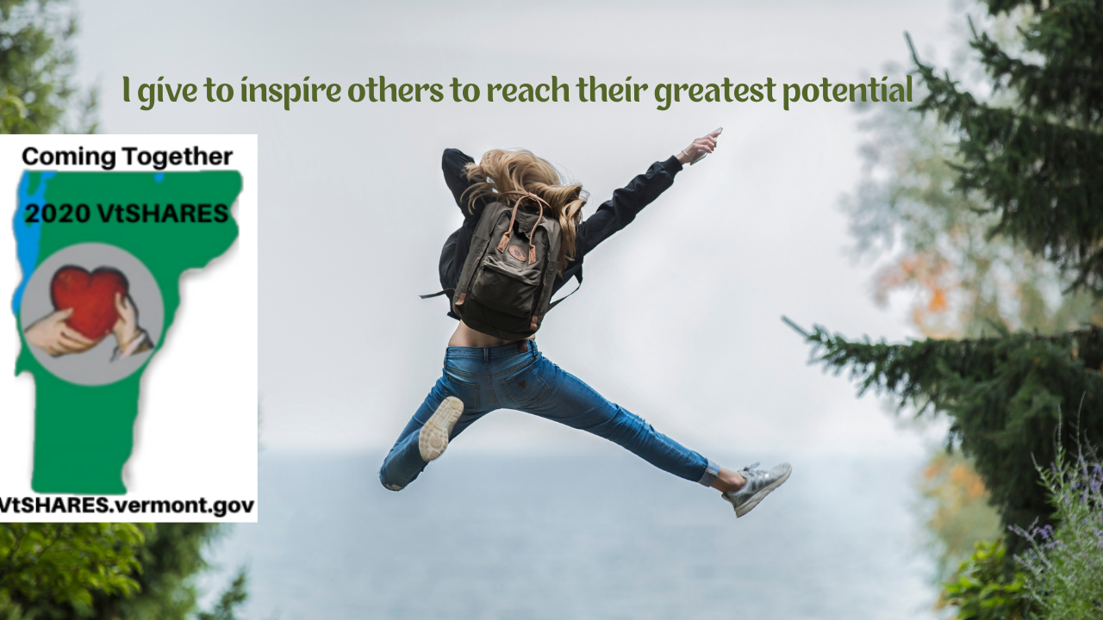

Virtual Backgrounds

Hello! Hello!

Looking for a fun background for your virtual meetings? Look no further! There are more than 10 to choose from on the VtSHARES website that speak to various areas that campaign pledges support. Please consider using these backgrounds to help raise awareness of those in our communities that could use our support, especially this year during the pandemic.

If there’s a specific area of interest you’d like a background created for, please email vtshares@vermont.gov and they’ll do their best to create one for you!

Thanks for all you do!
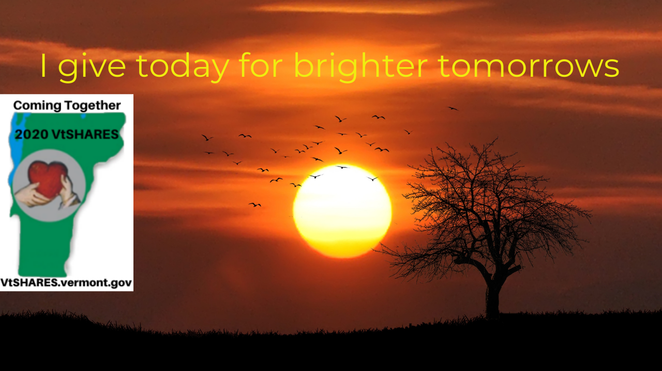

Follow-up/Motivational Message 1
Greetings everyone,
Can we possibly get 100% participation in our agency/department?? How cool would that be? Please remember that every contribution helps, that is the power behind combining so many donations.
Let's exceed our contributions this year!
VtSHARES Campaign is online with great information and nonprofit organization codes at http://vtshares.vermont.gov/
Thanks to all of you.

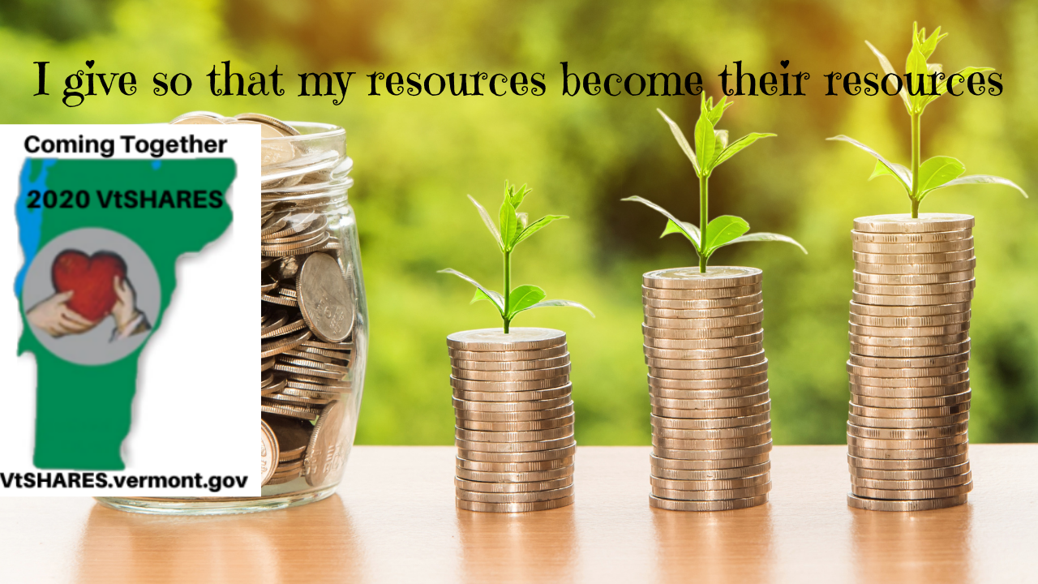

Follow-up/Motivational Message 2

Recently, while scrolling through some light reading, I came across the following article - 5 Ways Giving Is Good for You | Greater Good Magazine. In it the author references five ways how, as the title articulates, giving is beneficial for you and offers some science behind each claim.

Now, I must admit, for a long time I was under the impression that to give meant that you had to give selflessly with no expectation of getting something back in return. The thought of receiving something in exchange for giving, works completely against itself in my mind…. but is it true? Do I receive more than I give?
I will be the first to admit that the following offers a new, and maybe counterintuitive way, to think about giving and one that we should be sharing when asking others to participate!

- Giving makes us feel happy. A 2008 study by Harvard Business School professor Michael Norton and colleagues found that giving money to someone else lifted participants’ happiness more that spending it on themselves.

- Giving is good for our health A wide range of research has linked different forms of generosity to better health, even among the sick and elderly.

- Giving promotes cooperation and social connection When you give, you’re more likely to get back: Several studies, including work by sociologists Brent Simpson and Robb Willer, have suggested that when you give to others, your generosity is likely to be rewarded by others down the line.

- Giving evokes gratitude Whether you’re on the giving or receiving end of a gift, that gift can elicit feelings of gratitude—it can be a way of expressing gratitude or instilling gratitude in the recipient. And research has found that gratitude is integral to happiness, health, and social bonds.

- Giving is contagious When we give, we don’t only help the immediate recipient of our gift. We also spur a ripple effect of generosity through our community.

You really do receive more than you give. Won’t you please join me in giving this year for a better Vermont?
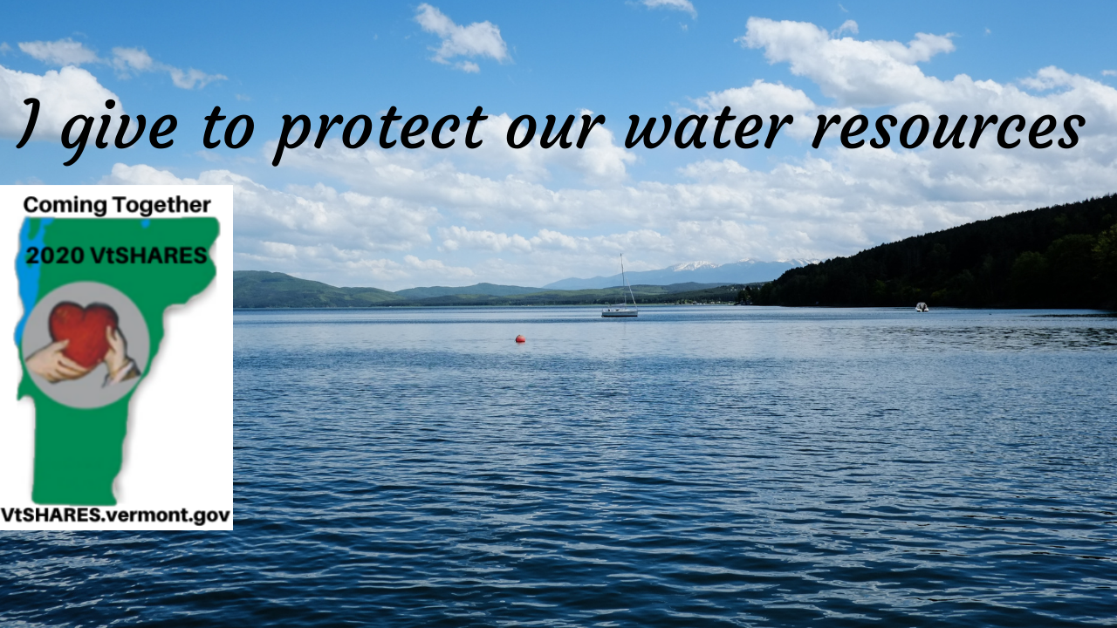

Follow-up/Motivational Message 3 – Thank you!

Greetings!

I just want to take a moment to truly THANK YOU for your caring hearts and service! Whether it’s taking a moment to reach out to a neighbor in need, sending a card to someone who might not have much interaction with others during this pandemic, or serving your community in some other way, thank you!

Spreading kindness and awareness is what VtSHARES is truly about. And if donating to local nonprofits is a way you’d also like to contribute, please visit the VtSHARES website for a quick and easy way to do so through payroll deductions.

Once again, my sincere gratitude for who you are and all you do!

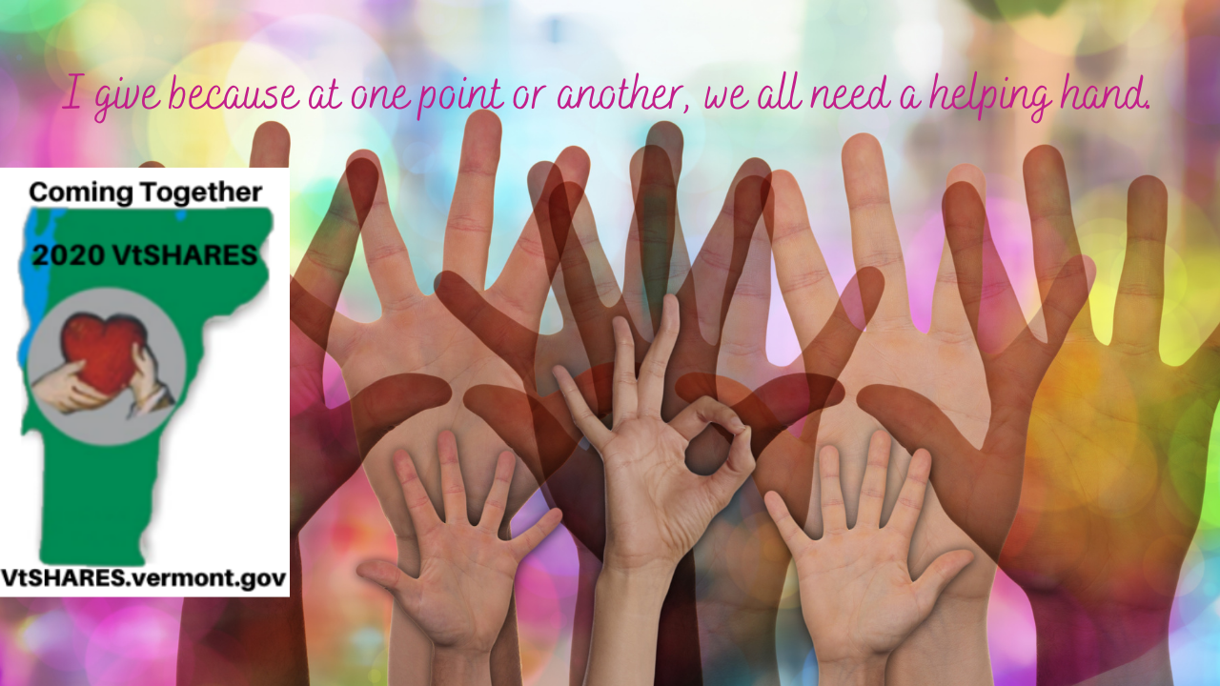

Follow-up/Motivational Message 4

What is responsibility? … Well, it’s our ability-to-respond.

Our ability to respond. All of us have an ability to respond. We respond constantly throughout the day. We respond to our co-workers, we respond to emails, we respond to tasks, and so on. Yet, when we look beyond what is put in front of us daily to respond to, there is always this outer layer of things that need a response. Things that are easily ignored when we look away. We see someone on the street without a home, we see children and families in our neighborhoods without daily necessities like food, clothes and heat, we see children entering a time in their life where they are the most easily influenced and entering a world where the opioid epidemic is rampant. If we are honest with ourselves, when we really stop and look around, there is a lot around us that needs a response.

One of the most beautiful things about VtSHARES is how much easier and do-able it makes our ability to respond. It doesn’t matter how much you give. Most of us think when we contribute to a cause, it must be a substantial amount right then. But I’m here to say no, it doesn’t… $1 a week is easier than $100 today, or even $100 next week. $1 a week for an entire year is only $52.00. For some of us, that’s a tank of gas, if we’re lucky – it’s two. $52 can provide 85 meals for food insecure Vermonters. If each state employee donated $1 a week for an entire year, that is over $400,000 that gets poured into our local communities. If we are truly honest with ourselves, most of us could afford to give more than $1 a week. Suddenly, our ability to respond becomes more doable, doesn’t it?

VtSHARES Campaign is now on-line. Take a look at the nonprofit organization codes to see if there is something you want to respond to: https://vtshares.vermont.gov/content/nonprofit-organizations .
Thanks to all of you.
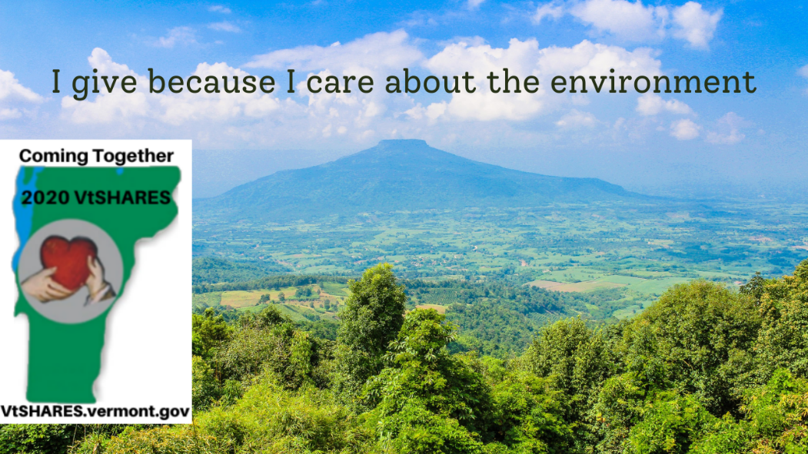

Follow-up/Motivational Message 5 – Why do you give?

Happy day team!

One of the many reasons I give to VtSHARES is they inspire me to bring awareness to local nonprofits working so hard to serve those in need. Two I’d like to highlight that could use our support, especially this year during the COVID-19 pandemic are:

Central Vermont Council on Aging supports Central Vermonters to age with dignity and choice. Services include meals on wheels, long-term care coordination, Medicare help, family caregiver supports, helpline, volunteers, healthy aging and wellness activities. (VtSHARES code 12-260)

The Vermont Foodbank’s mission is to gather and share quality food and nurture partnerships so that no one in Vermont will go hungry. They distribute millions of pounds of food annually through their 215 partner food shelves and meal sites. They also distribute food directly through a variety of programs focusing on youth and older adults. (VtSHARES code 12-610)

What is your reason to give? If you’d like to share your personal testimonial, please send to vtshares@vermont.gov. They’d love to include it on their website to inspire others (and spoiler alert –Campaign Ambassadors of offices with the most participation in sharing of personal testimonials will be in the running to win an award).

Thank you for all the reasons you choose to give in your own ways!

Follow-up/Motivational Message 6

Hello Team!

How many of us would love to boost office morale? Even the most pleasant of offices would say “YES!” to a morale boost; I mean, have you ever heard of an office having too high morale?!

Recently, I read an article in Forbes magazine, How Charitable Giving Can Boost Office Morale While Helping the Community The article was fascinating and as I read it, I found that VtSHARES offers all the pieces that this article claims to be “most important” in a workplace campaign.
- Choose the right cause – That is exactly what VtSHARES allows you to do! While some workplace campaigns offer a single or a few nonprofit organizations to choose from, VtSHARES offers the opportunity to the employee to choose the right cause for them!
- Voluntary Participation – VtSHARES is completely voluntary. It’s not something you have to do, and the electronic pledge system allows employees added privacy to their donation!
- Increases Networking – Sometimes YOU are the link between the State and the nonprofit organization you want to see participate in VtSHARES. Increase your network by connecting with the Committee or a local nonprofit to see how you can help!
- Convenience – You don’t even have to leave the office, or your desk for that matter. From the comfort of your workspace, you can make a huge impact on your local community.

And lastly, my favorite…

5) Improve Office Morale – As each person chooses to participate, they are left with a feeling of providing a greater impact on their community. This feeling boost employee morale, which in turn can positively affect their colleagues and workplace.

Now is the time to take advantage of this campaign and boost office morale! Visit the VtSHARES website at http://vtshares.vermont.gov/ to see if there is a nonprofit organization you would like to see benefit from your participation.

With great appreciation and respect,
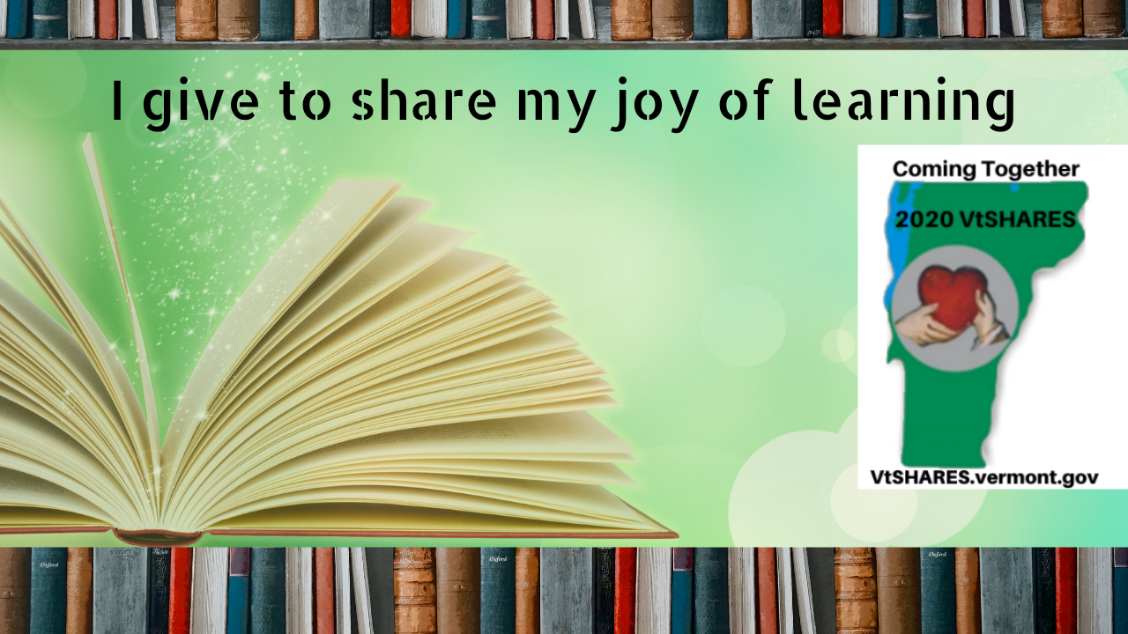

Follow-up/Motivational Message 7 – Thank you!

Good morning team,

“We often take for granted the very things that most deserve our gratitude.” – Cynthia Ozick.

I didn’t want to let another moment go by without thanking YOU for all you do for our office, the State and in your personal life. It’s people like you that make Vermont a beautiful state to live, work and play in, thank you!

And many thanks to the nonprofits serving our communities and the work they do. If you’d like to support their ongoing efforts, you’re welcome to contribute through payroll deductions via the VtSHARES Campaign, which is underway through October 23rd this year.

Again, thank you!

Follow-up/Motivational Message 8

Good morning everyone,

In case you hadn’t heard, or you flagged the earlier emails to come back to, but they have somehow gotten buried, this is a reminder that it is VtSHARES time! Everything is electronic, including the pledge card, which can be found online at http://vtshares.vermont.gov/.

You can look up what nonprofit organizations are participating this year, as well as make your donation online through the Online Pledge Card This system provides added security and privacy, should you choose to participate, and a bonus… it’s really easy!

VtSHARES is a great way to take advantage of an extremely easy way to impact your communities, through payroll deduction. It is also a fantastic way to take advantage of the Vermont Charitable Contribution Tax Credit. To learn more about the Tax Credit, visit the Charitable Contribution Tax Credit | VtSHARES Campaign.

Should you decide to participate, XXX has decided to go the extra mile and create a raffle of sorts. It’s completely voluntary, but if you choose to participate in VtSHARES, shoot XXX an email and your name will go into a drawing for a sweet surprise!

If we each do a little, together we can do a lot!

With much appreciation,
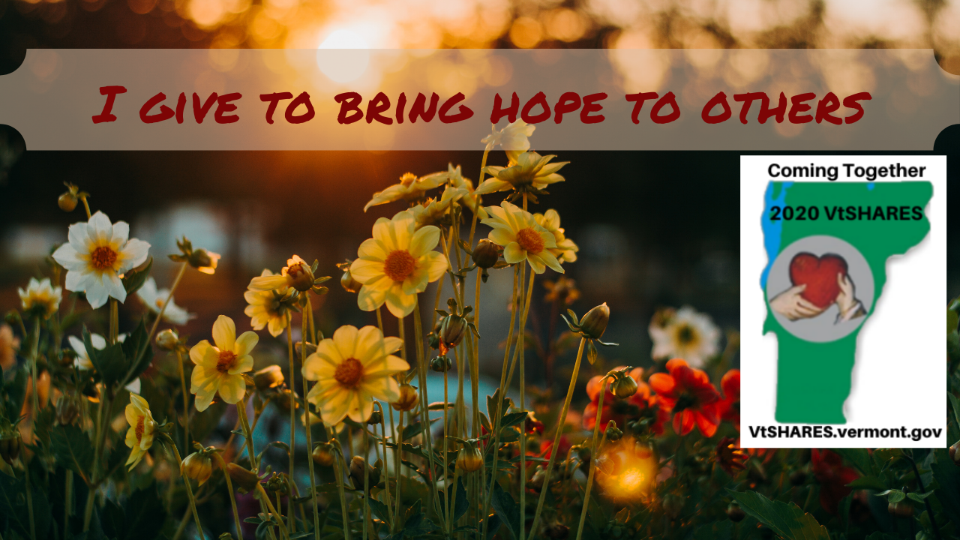

Follow-up/Motivational Message 9 – One Week Left of Campaign

Only a week left to this year’s campaign. Have you had a moment to read success stories on the VtSHARES website? So many of us know someone that was helped because others were generous enough to donate to a nonprofit organization. Hospice? Literacy? Environment? Humane treatment? Whatever speaks to your heart, you’ll find a nonprofit organization in our list to match.

If you’re willing to share your testimonial as to why you pledge, please email it to vtshares@vermont.gov to be included on the website. In addition, I will be considered for a Campaign Ambassador Caring and Sharing Award.

Thank you for taking the time to consider contributing to this year’s VtSHARES campaign.

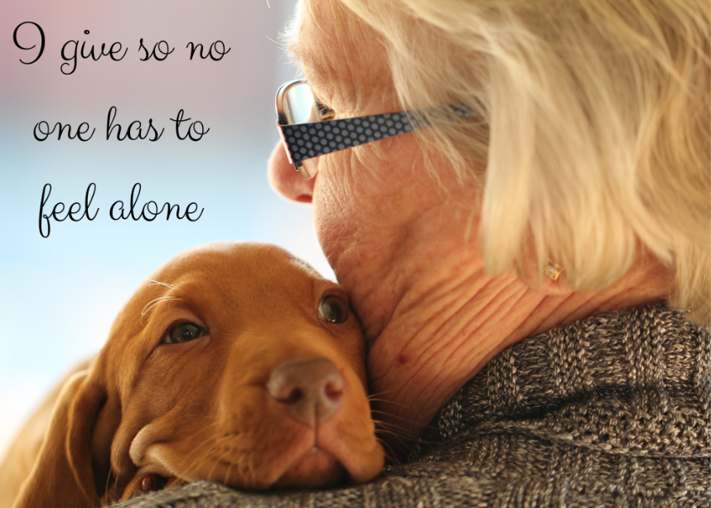

Follow-up/Motivational Message 10 – One Week Left of Campaign

Only a week left to this year’s campaign and we’re working hard to exceed last year’s contributions. For those who have already pledged, thank you from the bottom of my heart!

For those who have not yet determined how best to contribute, know that a pledge of $1 per pay period equals $26, which can provide a gas card for a victim of domestic violence to get to court hearing; provide 100 servings of nutritious produce to feed low income seniors; or allow a day of kayaking in a State park for adults with mobility impairment.

Thank you for taking the time to consider contributing to this year’s VtSHARES campaign.

Follow-up/Motivational Message 11 – Final Week

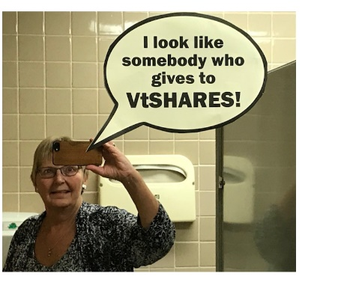

Hello Everyone!

Well, it’s hard to believe that we’re quickly coming up on the final week of this year’s VtSHARES Campaign! If you haven’t decided which nonprofit organization you plan to contribute to, or even if you will be contributing this year, please take a moment to look over the amazing nonprofit organizations that make such a difference in the lives of Vermonters who benefit from them every day.

Remember ~ it’s not how much one person contributes that matters, it’s all the donations together that make these valuable services available to those who find themselves in need. In fact, check out what a dollar can do. Please know YOU CAN make a difference!

Follow-up/Motivational Message 12 – To Exceed Your Goals

We are only XXX VtSHARES contributions away from surpassing the total amount of last year’s contributions! That’s right…. Just XXX!

It’s wonderful to see how we all come together to help and support those whose lives have been touched by hardships on so many levels. It’s our contributions that make the difference!

Let’s beat last year’s number for total contributions!
And don’t forget to send me an email to let me know if you’ve contributed to this year’s Campaign, as I’ll be holding a drawing for a VERY sweet surprise at the end of the Campaign.

Thank you all!

Thank you after the campaign – Message 13

Thank you all for such a positive VtSHARES campaign. The stories shared have made me much more aware of just how much this campaign touches the lives of the Vermonters we serve.

Our Agency/Department combined to pledge $XXXX – beating our goal by $YYY!

Thank you, thank you, thank you. Your contributions are deeply appreciated.

